# Lesson 30 – enviro:bit and scroll:bit Worksheet

You should decide with your partner who is going to program the enviro:bit and who is going to program the scroll:bit. There are separate instructions depending on which element you are producing.

Install either the enviro:bit or scroll:bit software library by clicking on the cog and then selecting extensions. Search for scroll:bit or enviro:bit and install the library.

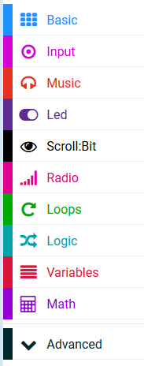

As you are going to be writing code to communicate between two different micro;bits it is important that you use the same channel. For the purpose of these instructions we are going to use channel 1. Set the micro:bits to use the same channel by place the ***radio set group*** block inside of an ***always*** loop.



# enviro:bit Instructions

You are going to write code to send three sensor readings to the other micro:bit. When the eniro:bit receives a request from the scroll:bit it will measure three readings and send them via radio to the micro:bit attached to the scroll:bit.

From the **Input** group create an ***on button A pressed*** selection statement.



From the radio group choose the ***on radio received receivedString*** block.

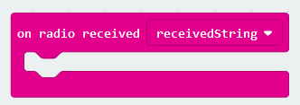

From the radio group drag in the ***radio send number*** block.

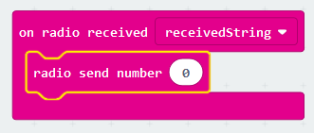

Select the enviro:bit group and then click on **Air & Weather**.



Drag the ***get temperature*** block and place it inside of the block which currently says **0**.

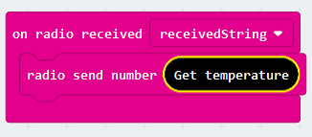

Repeat the process for Pressure and Humidity.

You should then have the following code.

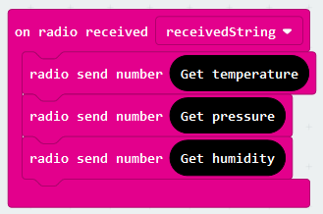

Upload this file to the micro:bit which has the enviro:bit connected to it.

Once activated, the micro:bit will transmit three numerical values to the micro:bit connected to the scroll:bit.

# scroll:bit Instructions

You are going to program the device to display text on the scroll:bit and the sensor readings on the micro:bit. To start the communication between the two devices you are going to send a text string when the A button is pressed.

From the **Input** group select ***on button A pressed***.

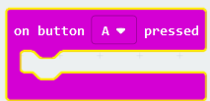

Create a new variable called **labelPosition**. This will be used to find which position the text label is within a data structure called an array.

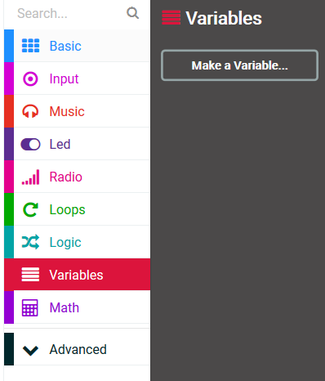

You will then see:

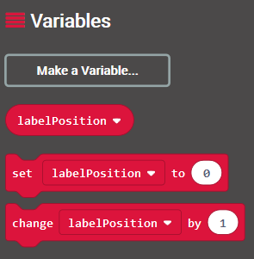

Select the ***set label position to 0*** block and drag it inside of the ***on button A pressed block***.

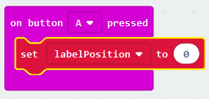

To trigger the readings to be sent you need to send a text string to the enviro:bit.

Choose the ***radio send string*** block and type “Update weather readings” as the text.

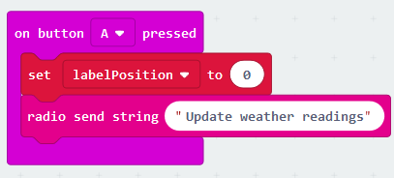

When the A button is pressed the micro:bit will receive three numbers. We then need to define what we want to do with those numbers. Select an ***on radio received'receivedNumber*** block from the radio group.

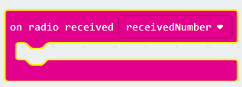

We are now going to use a data structure called an array. This is a list of different items, one after another. We can refer to each item by its position. For example, the first item of text is referred to as position 0. To create an array, you need to click on **Advanced** and then **Arrays**.

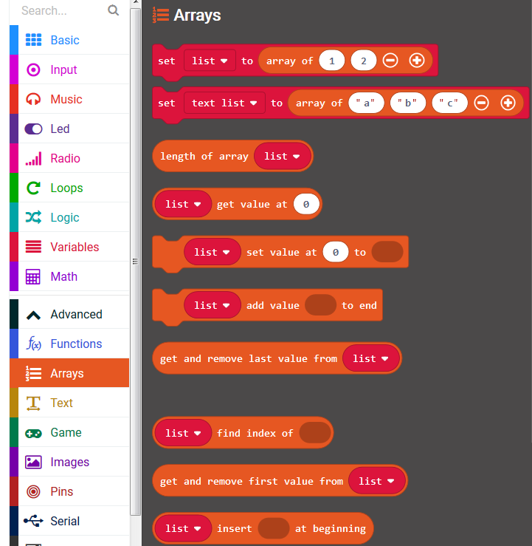

You then need to drag in the block that says ***set text list to array of “a” “b” “c”*** into the on ***radio received*** block.

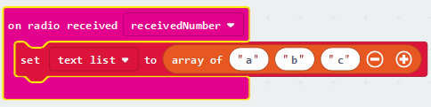

The first number that the micro:bit will receive will be the Temperature, the second will be the Pressure and the third will be the Humidity. You need to type these labels into the array as follows.

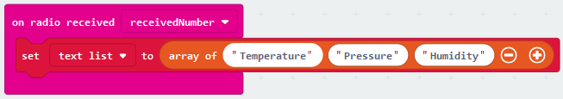

You are now going to program the actual scroll:bit. We are going to use the scroll:bit to display the label that is in the array. To do this, select the following block and place it in the ***on radio receivedNumber*** block.



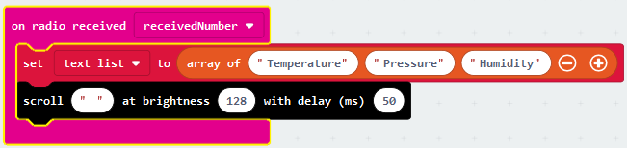

From the **Arrays** section, selection the ***list get value at 0*** block:

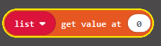

Place it inside of the “ ” in the ***scroll*** block:

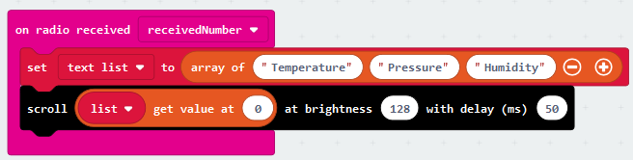

The first number that is received, we would like it to display position 0, i.e. Temperature. After the second number is received, we want it to display position 1, i.e. Pressure. To do this we need to replace the 0 with the **labelPosition** variable that we defined earlier.

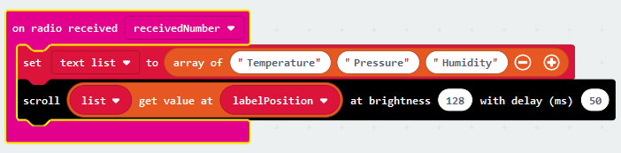

This will display the text label. We then want to display the number that has been received on the built-in micro:bit display. To do this, select a ***show number*** block from the **Basic** set of commands and drag into it ***receivedNumber*** from the **Radio** set.

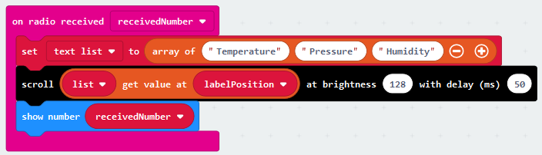

When the next number is received we want to display the next text label in the array. To do this we need to change the **labelPosition** variable by 1 as follows.

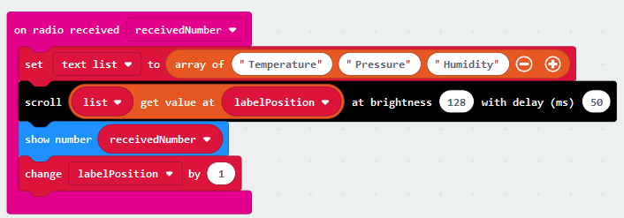

Congratulations, you have now finished coding your micro:bit.